TURNER FITNESS COACHING 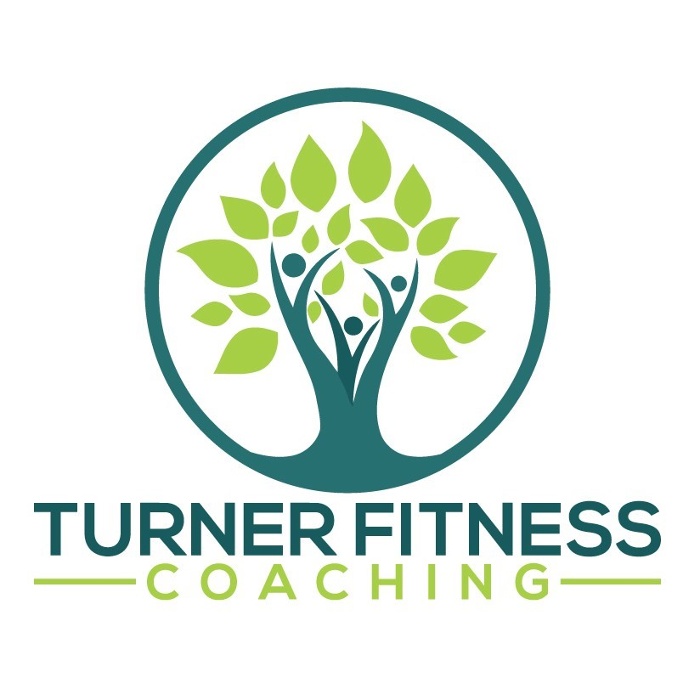
Think you have “run” out of time to enjoy running? Turner Fitness Coaching begs to differ
Comprehensive 3 month program allows for dreams to become reality
BOSTON, MA, March 4, 2022—Turner Fitness Coaching recently launched a new program dubbed the “Running RE-BOOT Camp”. The Running RE-BOOT Camp focuses on helping individuals ages 30-60 regain trust and confidence in their own ability to continue to become stronger—it does not stop simply because an individual may not be in college (or in their 20s) anymore—success and results can be found at any age!
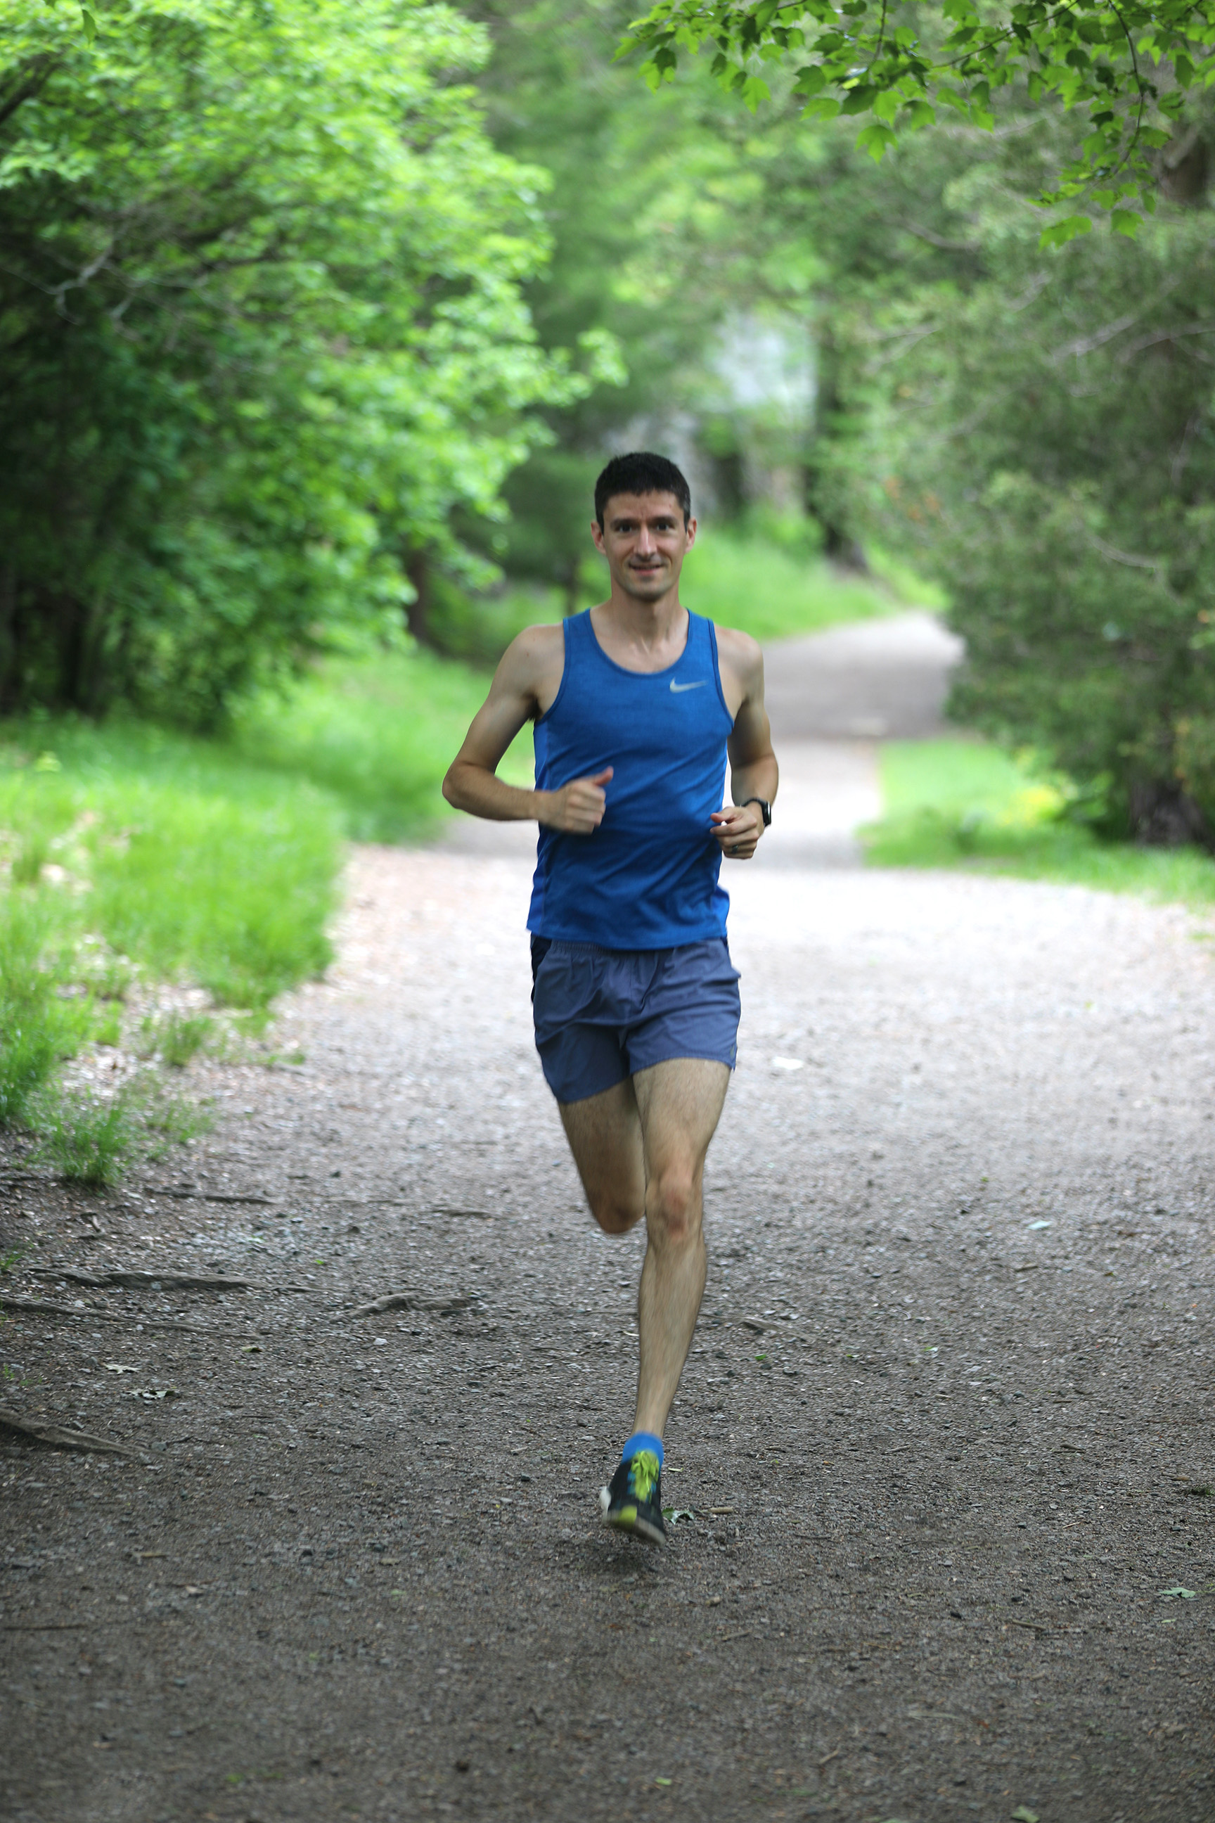
Turner Fitness Coaching’s RE-BOOT Camp offers individuals' practical ways to:
- Become stronger than ever after an injury
- Reduce injury in the future
- Incorporate effective strength training, no matter experience level
- Correctly use pacing strategies to improve speed
- Safely challenge oneself regarding agility
- Maintain durability as a runner
“I want people to see running as a learnable skill, that they can work at to improve, so that they feel better doing it, can run for longer, and continue doing it in their 70's, 80's and beyond.” Colin Turner, Founder of Turner Fitness Coaching, says. “I think too many people see running as something you are good at or bad at.”
What is holding you back from “running” towards that marathon you have always wanted to do, or having the motivation to keep running with consistency like you did in college? Will you have the courage to “just start”?
To learn more, go to https://turnerfitnesscoaching.com/running-re-bootcamp/.
ABOUT TURNER FITNESS COACHING
Turner Fitness Coaching believes everyone can run, running should be fun, and injuries are optional! Founder Colin Turner started Turner Fitness Coaching to help struggling runners learn to avoid injury and love running again. After years of chronic pain and injury in his 30's, he discovered that most of what he knew about running was wrong. In his research, Turner found that anyone can learn how reducer risk of injury to almost 0%! With his background in personal training, he created a 3-month course to teach runners the fundamentals of how to be more durable and resilient, so they can run without injury for life!
CONTACT
Colin Turner
Colin@turnerfitnesscoaching.com

